1. Update the following code so that the values in array b is ‘x’ more than the corresponding values in array a. You can only write only one line of code inside the loop (in the comment section marked “Write Code Here”). Do not modify anything else. (10)

int n = 10;

int x = 5;

int index = 0;

int a[] = {12, 7, 3, 71, 2, 43, 38, 23, 45, 22};

int b[n];

for (int i=0; i<n; i++) {

//Write Code Here

}

1. char s = “america”

What is wrong with this C statement. Mark the errors and fix them. (4)

1. Suppose you want to declare an array of size 15 and the elements of the array will be in a geometric progression, the first one starting with 1 and the common ratio being 2. For example, the first few elements of that array will be 1, 2, 4, 8, 16 , … and so on. Write a for loop to initialize the array with the required progression. (10)

1. To declare a string, Fahim uses the following code. What will happen in the second and the third statement. Explain. (10)

char a[10];

a[0] = 98;

a[1] = 97;

a[2] = 'n';

a[3] = 'a';

a[4] = 'n';

a[5] = 'a';

a[6] = ‘\0’;

1. Consider the following code.

char a[10];

char ch = ‘a’;

for(i = 0; i<8;i++)

{

a[i] = ch+8-i;

}

a[8] = ‘\0’;

What will be stored in the given character array ‘a’ of the question after the execution of the block of code? (10)

1. How much bytes does an int type array with 12 elements take in memory? (10)

1. What does lexicographical comparison mean? Explain with examples. How can we order strings in lexicographic order in C? (10)
2. What does ASCII value of a character mean? How can you print the ASCII value of a character in C language? (10)
3. Explain Bubble Sorting. Suppose you are given an array of integers 12, 7, 9, 1, 3, 73, 11, 15, 62, 19, 4. What will be the sequence of these integers if we run Bubble sort for only 5 iterations? (10)
4. How can you find the sum of digits of a number? Write a C program that will extract the digits of the given integer number as input and add them to find the required output. For example, if the input is 1235623, then the output will be 22. Because, 1+2+3+5+6+2+3 = 22. (6)
5. You will be given a 3x3 matrix as input. You need to check whether the matrix is a magic square or not. Magic squares are the matrices which have equal sum along all rows, columns and diagonals. For example,

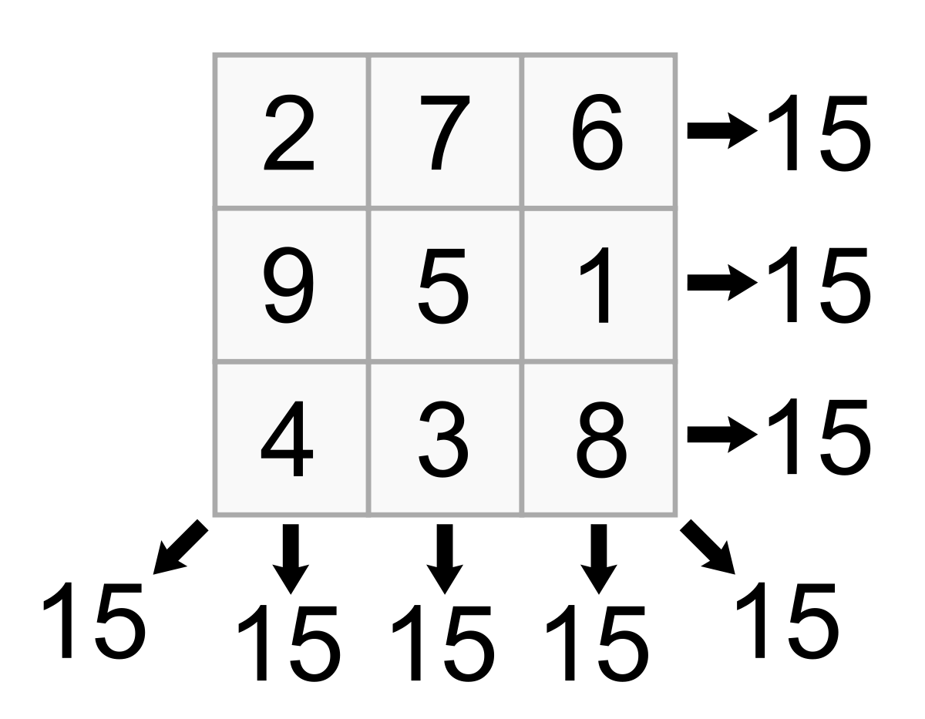

This is a magic square as you can see all the sums are equal to 15 along all the rows and columns and even the diagonals.

Now,Write a C Program to check the matrix is magic square or not. (10)

|  |  |
| --- | --- |
| **Sample Input** | **Sample Output** |
| 2 7 6  9 8 1  4 3 5 | NO |
| 2 7 6  9 5 1  4 3 8 | YES |

**Answer Script**

|  |
| --- |
|  |
|  |
| int n = 10;  int x = 5;  int index = 0;  int a[] = {12, 7, 3, 71, 2, 43, 38, 23, 45, 22};  int b[n];  for (int i=0; i<n; i++) {  b[i]=a[i]+x;  } |
|  |

|  |
| --- |
| Question No. 02  char s = “america”  What is wrong with this C statement. Mark the errors and fix them. (4) |
|  |
| Answer No. 02  we saw that, there is a string declared but there are some wrong. let’s correct this error:  we know that string declare syntax is:  char variable[array_size];  we, use data type and variable name use[]this bracket and in this [] bracket we initialize the size(if we input this string we initialize size or if we initialize this string we don’t need to declared size). and at least we must be use (;)semicolon.  in this string we saw that we declared data type ,variable name but we did not use []this bracket. and we did not close this string using (;)semicolon. the main error is  //first error is without using [] this bracket  //second error is doesn't using semicolon(;).  the correct string is:  char s[]="america";  or,  char s[7]="america"; |
|  |

|  |
| --- |
| Question No. 03  Suppose you want to declare an array of size 15 and the elements of the array will be in a geometric progression, the first one starting with 1 and the common ratio being 2. For example, the first few elements of that array will be 1, 2, 4, 8, 16 , … and so on. Write a for loop to initialize the array with the required progression. (10) |
|  |
| Answer No. 03 |
|  |

|  |
| --- |
| Question No. 04  To declare a string, Fahim uses the following code. What will happen in the second and the third statement. Explain. (10)  char a[10];  a[0] = 98;  a[1] = 97;  a[2] = 'n';  a[3] = 'a';  a[4] = 'n';  a[5] = 'a';  a[6] = ‘\0’; |
|  |
| Answer No. 04  in this code the third statement is: **a[0] = 98;**  in this char a array 0-th position is declared by **98,** That is ASCII value. this ASCII value represent by the smaller latter **b.** then **98** converted by **b.**  now the third statement is: **a[1] = 97**;  the char array 1-th position declared by **97**. that is ASCII value. This ASCII value represent by the smaller letter **a**. then **97** converted by (**a**)  if we continue this code we find the output is :  banana |
|  |

|  |
| --- |
| Question No. 05  Consider the following code.  char a[10];  char ch = ‘a’;  for(i = 0; i<8;i++)  {  a[i] = ch+8-i;  }  a[8] = ‘\0’;  What will be stored in the given character array ‘a’ of the question after the execution of the block of code? (10) |
|  |
| Answer No. 05  after this execution of this block of this code    first of all, the character of 'a' is converted by his Ascii value  97.  After enter this for loop when i=0 then condition is true and  enter the for loop and a[0]=97+8-0=105 s ASCII character is i  loop is continuously running i-th value when 7. then  i++;  a[1]=97+8-1=104='h'//i=1  i++;  a[2]=97+8-2=103='g'//i=2  i++;  a[3]=97+8-3=102='f'//i=3  i++;  a[4]=97+8-4=101='e'//i=4  i++;  a[5]=97+8-5=100='d'//i=5  i++;  a[6]=97+8-6=99='c'//i=6  i++;  a[7]=97+8-7=98='b'//i=7  i++;  after when i is 8 then this loop break and outside of this loop and  find a[8]='\0'  if we print this then output become this type:  ihgfedcb |
|  |

|  |
| --- |
| Question No. 06  How much bytes does an int type array with 12 elements take in memory? (10) |
|  |
| Answer No. 06 |
|  |

|  |
| --- |
| Question No. 07  What does lexicographical comparison mean? Explain with examples. How can we order strings in lexicographic order in C? |
|  |
| Answer No. 07 |
|  |

|  |
| --- |
| Question No. 08  What does ASCII value of a character mean? How can you print the ASCII value of a character in C language? |
|  |
| Answer No. 08 |
|  |

|  |
| --- |
| Question No. 09  Explain Bubble Sorting. Suppose you are given an array of integers 12, 7, 9, 1, 3, 73, 11, 15, 62, 19, 4. What will be the sequence of these integers if we run Bubble sort for only 5 iterations? |
|  |
| Answer No. 09 |
|  |

|  |
| --- |
| Question No. 10  How can you find the sum of digits of a number? Write a C program that will extract the digits of the given integer number as input and add them to find the required output. For example, if the input is 1235623, then the output will be 22. Because, 1+2+3+5+6+2+3 = 22. |
| Answer No.  10  #include<stdio.h>  int main()  {  long long int num,temp,r,sum;  scanf("%lld",&num);  temp=num;  sum=0;  while(temp!=0)  {  r=temp%10;  sum=sum+r;  temp=temp/10;  }  printf("%lld\n",sum);  return 0;  } |
| Question No. 11  You will be given a 3x3 matrix as input. You need to check whether the matrix is a magic square or not. Magic squares are the matrices which have equal sum along all rows, columns and diagonals. For example,    This is a magic square as you can see all the sums are equal to 15 along all the rows and columns and even the diagonals.  Now, Write a C Program to check the matrix is magic square or not. (10)   |  |  | | --- | --- | | **Sample Input** | **Sample Output** | | 2 7 6  9 8 1  4 3 5 | NO | | 2 7 6  9 5 1  4 3 8 | YES | |
|  |
| Answer No.  11  #include<stdio.h>  int main()  {  int row,col,sum1=0,sum2=0,f=0,sum3=0,sum4=0;  scanf("%d %d",&row,&col);  int a[row][col];  int i,j;  if(row==col)  {  for( i=0; i<row; i++)  {  for( j=0; j<col; j++)  {  scanf("%d",&a[i][j]);  }  }  for( i=0; i<row; i++)  {  for( j=0; j<col; j++)  {  if(i==j)  {  sum1=sum1+a[i][j];  }  if(i+j==3-1)  {  sum2=sum2+a[i][j];  }  }  }  if(sum1!=sum2)  {  f=1;  }  else  {  for( i=0; i<row; i++)  {  sum3=0;  sum4=0;  for( j=0; j<col; j++)  {  sum3=sum3+a[i][j];  sum4=sum4+a[i][j];  }  if(sum4!=sum1)  {  f=1;  }  else if(sum3!=sum1)  {  f=1;  }  else  {  f=0;  }  }  }  if(f==0)  {  printf("YES\n");  }  else  {  printf("NO\n");  }  }  else  {  printf("NO\n");  }  return 0;  } |
|  |